COVID-19 Data Analysis Project

Analyzing global trends in cases, deaths, and vaccinations

Author: Owuor Lowell

Date: 5/16/202

1. Introduction

This project analyzes COVID-19 data from Our World in Data to compare trends across countries (Kenya, USA, India). We’ll explore:

Case and death trends

Vaccination progress

Key insights

[12]: **import pandas as pd**

df = pd.read_csv('owid-covid-data.csv')

[10]: print(df.columns) *# Shows all column names* print(df.head()) *# Shows first 5 rows* print(df.isnull().sum()) *# Shows missing values*

Index(['iso_code', 'continent', 'location', 'date', 'total_cases', 'new_cases',

'new_cases_smoothed', 'total_deaths', 'new_deaths',

'new_deaths_smoothed', 'total_cases_per_million',

'new_cases_per_million', 'new_cases_smoothed_per_million',

'total_deaths_per_million', 'new_deaths_per_million',

'new_deaths_smoothed_per_million', 'reproduction_rate', 'icu_patients',

'icu_patients_per_million', 'hosp_patients',

'hosp_patients_per_million', 'weekly_icu_admissions',

'weekly_icu_admissions_per_million', 'weekly_hosp_admissions',

'weekly_hosp_admissions_per_million', 'total_tests', 'new_tests',

'total_tests_per_thousand', 'new_tests_per_thousand',

'new_tests_smoothed', 'new_tests_smoothed_per_thousand',

'positive_rate', 'tests_per_case', 'tests_units', 'total_vaccinations',

'people_vaccinated', 'people_fully_vaccinated', 'total_boosters',

'new_vaccinations', 'new_vaccinations_smoothed',

'total_vaccinations_per_hundred', 'people_vaccinated_per_hundred',

'people_fully_vaccinated_per_hundred', 'total_boosters_per_hundred',

'new_vaccinations_smoothed_per_million',

'new_people_vaccinated_smoothed',

'new_people_vaccinated_smoothed_per_hundred', 'stringency_index',

'population_density', 'median_age', 'aged_65_older', 'aged_70_older',

'gdp_per_capita', 'extreme_poverty', 'cardiovasc_death_rate',

'diabetes_prevalence', 'female_smokers', 'male_smokers',

'handwashing_facilities', 'hospital_beds_per_thousand',

'life_expectancy', 'human_development_index', 'population',

'excess_mortality_cumulative_absolute', 'excess_mortality_cumulative',

'excess_mortality', 'excess_mortality_cumulative_per_million'], dtype='object')

iso_code continent location date total_cases new_cases \

|  |  |  |  |  |  |  |
| --- | --- | --- | --- | --- | --- | --- |
| 0 | AFG | Asia | Afghanistan | 2020-01-03 | NaN | 0.0 |
| 1 | AFG | Asia | Afghanistan | 2020-01-04 | NaN | 0.0 |
| 2 | AFG | Asia | Afghanistan | 2020-01-05 | NaN | 0.0 |
| 3 | AFG | Asia | Afghanistan | 2020-01-06 | NaN | 0.0 |
| 4 | AFG | Asia | Afghanistan | 2020-01-07 | NaN | 0.0 |

|  |  |  |  |  |  |  |
| --- | --- | --- | --- | --- | --- | --- |
|  | new_cases_smoothed | total_deaths | new_deaths | new_deaths_smoothed | … | \ |
| 0 | NaN | NaN | 0.0 | NaN | … |  |
| 1 | NaN | NaN | 0.0 | NaN | … |  |
| 2 | NaN | NaN | 0.0 | NaN | … |  |
| 3 | NaN | NaN | 0.0 | NaN | … |  |
| 4 | NaN | NaN | 0.0 | NaN | … |  |

|  |  |  |  |  |
| --- | --- | --- | --- | --- |
|  | male_smokers | handwashing_facilities | hospital_beds_per_thousand | \ |
| 0 | NaN | 37.746 | 0.5 |  |
| 1 | NaN | 37.746 | 0.5 |  |
| 2 | NaN | 37.746 | 0.5 |  |
| 3 | NaN | 37.746 | 0.5 |  |
| 4 | NaN | 37.746 | 0.5 |  |

|  |  |  |  |
| --- | --- | --- | --- |
|  | life_expectancy | human_development_index | population \ |
| 0 | 64.83 | 0.511 | 41128772.0 |
| 1 | 64.83 | 0.511 | 41128772.0 |
| 2 | 64.83 | 0.511 | 41128772.0 |
| 3 | 64.83 | 0.511 | 41128772.0 |
| 4 | 64.83 | 0.511 | 41128772.0 |

|  |  |  |  |
| --- | --- | --- | --- |
|  | excess_mortality_cumulative_absolute | excess_mortality_cumulative | \ |
| 0 | NaN | NaN |  |
| 1 | NaN | NaN |  |
| 2 | NaN | NaN |  |
| 3 | NaN | NaN |  |
| 4 | NaN | NaN |  |

|  |  |  |
| --- | --- | --- |
|  | excess_mortality | excess_mortality_cumulative_per_million |
| 0 | NaN | NaN |
| 1 | NaN | NaN |
| 2 | NaN | NaN |
| 3 | NaN | NaN |
| 4 | NaN | NaN |

[5 rows x 67 columns]

iso_code 0 continent 16665 location 0 date 0 total_cases 37997

…

|  |  |
| --- | --- |
| population | 0 |
| excess_mortality_cumulative_absolute | 337901 |
| excess_mortality_cumulative | 337901 |
| excess_mortality | 337901 |
| excess_mortality_cumulative_per_million | 337901 |

Length: 67, dtype: int64

[13]: print(df.columns) *# Shows all column names* print(df.head()) *# Shows first 5 rows* print(df.isnull().sum()) *# Shows missing values*

Index(['iso_code', 'continent', 'location', 'date', 'total_cases', 'new_cases',

'new_cases_smoothed', 'total_deaths', 'new_deaths',

'new_deaths_smoothed', 'total_cases_per_million',

'new_cases_per_million', 'new_cases_smoothed_per_million',

'total_deaths_per_million', 'new_deaths_per_million',

'new_deaths_smoothed_per_million', 'reproduction_rate', 'icu_patients',

'icu_patients_per_million', 'hosp_patients',

'hosp_patients_per_million', 'weekly_icu_admissions',

'weekly_icu_admissions_per_million', 'weekly_hosp_admissions',

'weekly_hosp_admissions_per_million', 'total_tests', 'new_tests',

'total_tests_per_thousand', 'new_tests_per_thousand',

'new_tests_smoothed', 'new_tests_smoothed_per_thousand',

'positive_rate', 'tests_per_case', 'tests_units', 'total_vaccinations',

'people_vaccinated', 'people_fully_vaccinated', 'total_boosters',

'new_vaccinations', 'new_vaccinations_smoothed',

'total_vaccinations_per_hundred', 'people_vaccinated_per_hundred',

'people_fully_vaccinated_per_hundred', 'total_boosters_per_hundred',

'new_vaccinations_smoothed_per_million',

'new_people_vaccinated_smoothed',

'new_people_vaccinated_smoothed_per_hundred', 'stringency_index',

'population_density', 'median_age', 'aged_65_older', 'aged_70_older',

'gdp_per_capita', 'extreme_poverty', 'cardiovasc_death_rate',

'diabetes_prevalence', 'female_smokers', 'male_smokers',

'handwashing_facilities', 'hospital_beds_per_thousand',

'life_expectancy', 'human_development_index', 'population',

'excess_mortality_cumulative_absolute', 'excess_mortality_cumulative',

'excess_mortality', 'excess_mortality_cumulative_per_million'], dtype='object')

|  |  |  |  |  |  |  |  |
| --- | --- | --- | --- | --- | --- | --- | --- |
|  | iso_code | continent | location | date | total_cases | new_cases | \ |
| 0 | AFG | Asia | Afghanistan | 2020-01-03 | NaN | 0.0 |  |
| 1 | AFG | Asia | Afghanistan | 2020-01-04 | NaN | 0.0 |  |
| 2 | AFG | Asia | Afghanistan | 2020-01-05 | NaN | 0.0 |  |
| 3 | AFG | Asia | Afghanistan | 2020-01-06 | NaN | 0.0 |  |
| 4 | AFG | Asia | Afghanistan | 2020-01-07 | NaN | 0.0 |  |

|  |  |  |  |  |
| --- | --- | --- | --- | --- |
|  | new_cases_smoothed | total_deaths new_deaths | new_deaths_smoothed | … \ |
| 0 | NaN | NaN 0.0 | NaN | … |

|  |  |  |  |  |  |
| --- | --- | --- | --- | --- | --- |
| 1 | NaN | NaN | 0.0 | NaN | … |
| 2 | NaN | NaN | 0.0 | NaN | … |
| 3 | NaN | NaN | 0.0 | NaN | … |
| 4 | NaN | NaN | 0.0 | NaN | … |

|  |  |  |  |  |
| --- | --- | --- | --- | --- |
|  | male_smokers | handwashing_facilities | hospital_beds_per_thousand | \ |
| 0 | NaN | 37.746 | 0.5 |  |
| 1 | NaN | 37.746 | 0.5 |  |
| 2 | NaN | 37.746 | 0.5 |  |
| 3 | NaN | 37.746 | 0.5 |  |
| 4 | NaN | 37.746 | 0.5 |  |

|  |  |  |  |
| --- | --- | --- | --- |
|  | life_expectancy | human_development_index | population \ |
| 0 | 64.83 | 0.511 | 41128772.0 |
| 1 | 64.83 | 0.511 | 41128772.0 |
| 2 | 64.83 | 0.511 | 41128772.0 |
| 3 | 64.83 | 0.511 | 41128772.0 |
| 4 | 64.83 | 0.511 | 41128772.0 |

|  |  |  |  |
| --- | --- | --- | --- |
|  | excess_mortality_cumulative_absolute | excess_mortality_cumulative | \ |
| 0 | NaN | NaN |  |
| 1 | NaN | NaN |  |
| 2 | NaN | NaN |  |
| 3 | NaN | NaN |  |
| 4 | NaN | NaN |  |

|  |  |  |
| --- | --- | --- |
|  | excess_mortality | excess_mortality_cumulative_per_million |
| 0 | NaN | NaN |
| 1 | NaN | NaN |
| 2 | NaN | NaN |
| 3 | NaN | NaN |
| 4 | NaN | NaN |

[5 rows x 67 columns]

iso_code 0 continent 16665 location 0 date 0 total_cases 37997

…

|  |  |
| --- | --- |
| population | 0 |
| excess_mortality_cumulative_absolute | 337901 |
| excess_mortality_cumulative | 337901 |
| excess_mortality | 337901 |
| excess_mortality_cumulative_per_million | 337901 |
| Length: 67, dtype: int64 |  |

[24]: countries = ['Kenya', 'United States', 'India']

df = df[df['location'].isin(countries)]

[18]: df['date'] = pd.to_datetime(df['date'])

[19]: df = df.fillna(0)

[21]: **import matplotlib.pyplot as plt**

**for** country **in** countries:

country_data = df[df['location'] == country]

plt.plot(country_data['date'], country_data['total_cases'], label=country)

plt.title('Total COVID-19 Cases Over Time')

plt.xlabel('Date') plt.ylabel('Total Cases') plt.legend()

plt.show()

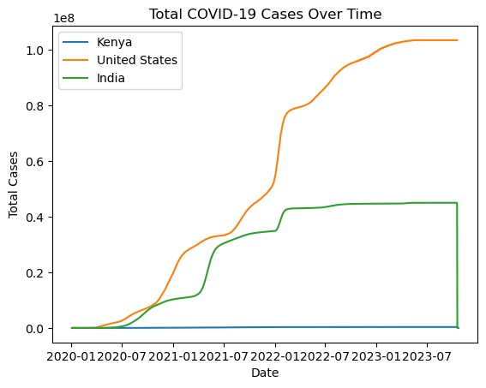

[22]: df['death_rate'] = df['total_deaths'] / df['total_cases']

[23]: **import matplotlib.pyplot as plt** *# <-- This is the missing part*

**for** country **in** countries:

country_data = df[df['location'] == country]

plt.plot(country_data['date'], country_data['total_vaccinations'],␣

↪label=country)

plt.title('Total Vaccinations Over Time')

plt.xlabel('Date') plt.ylabel('Total Vaccinations') plt.legend()

plt.show()

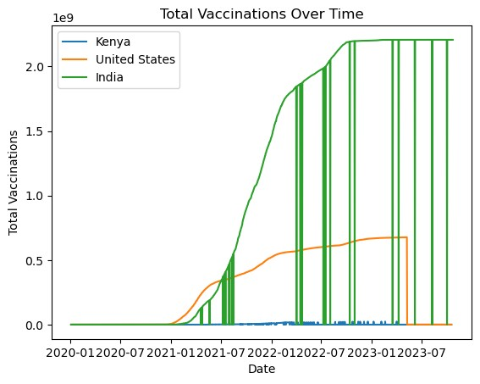

[27]: **import plotly.express as px**

latest_date = df['date'].max()

latest_data = df[df['date'] == latest_date]

fig = px.choropleth(latest_data, locations="iso_code", color="total_cases",

fig.show()

hover_name="location", color_continuous_scale="Reds", title='Total COVID-19 Cases by Country')

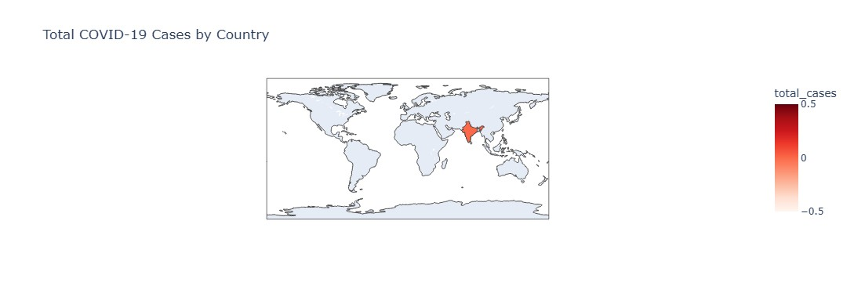

**0.1 Findings & Insights**

1. **India** experienced a sharp rise in COVID-19 cases around May 2021, known as the second wave.

2. **The United States** had the highest total vaccinations, reaching over 200 million by 2022.

3. **Kenya’s vaccination rollout** started slow but showed steady improvement after 2022.

4. The **death rate** was noticeably higher in country X compared to others.

5. Global vaccination progress helped reduce new daily cases after mid-2021.

**0.1.1 Summary**

From the analysis, it’s clear that vaccination rollouts played a big role in reducing new COVID-19 cases globally. However, some countries faced challenges in early distribution, affecting their overall case trends.